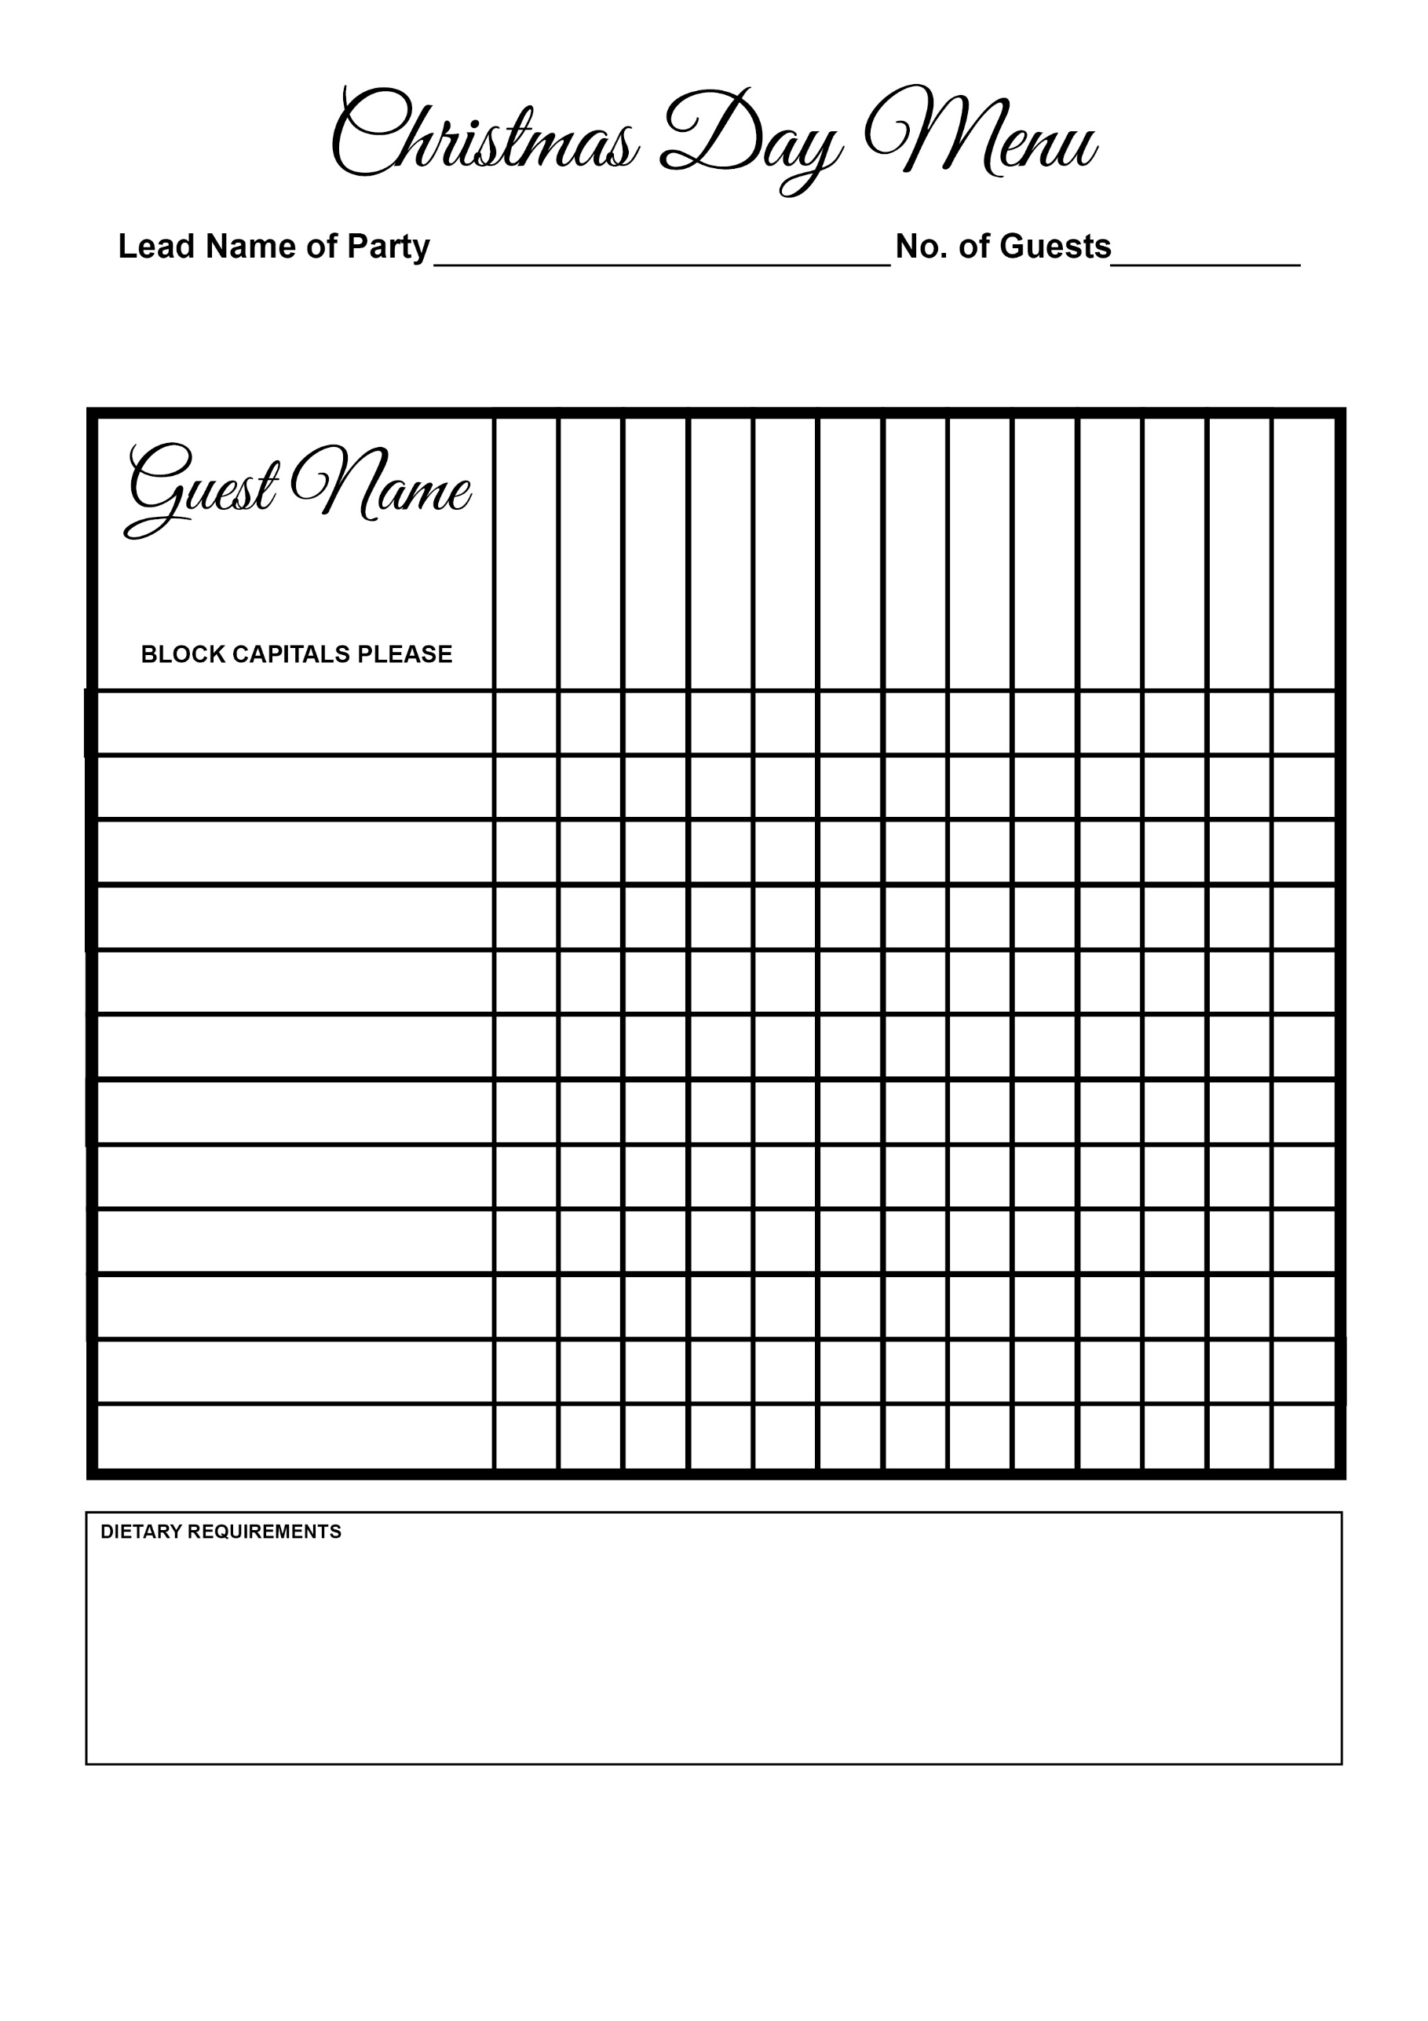

Christmas Pudding

Lobster Medallions

Brulee

Wellington

Cheese

Chocolate Cake

Seabass

Beef

Turkey

Agnolotti

Terrine

Soup