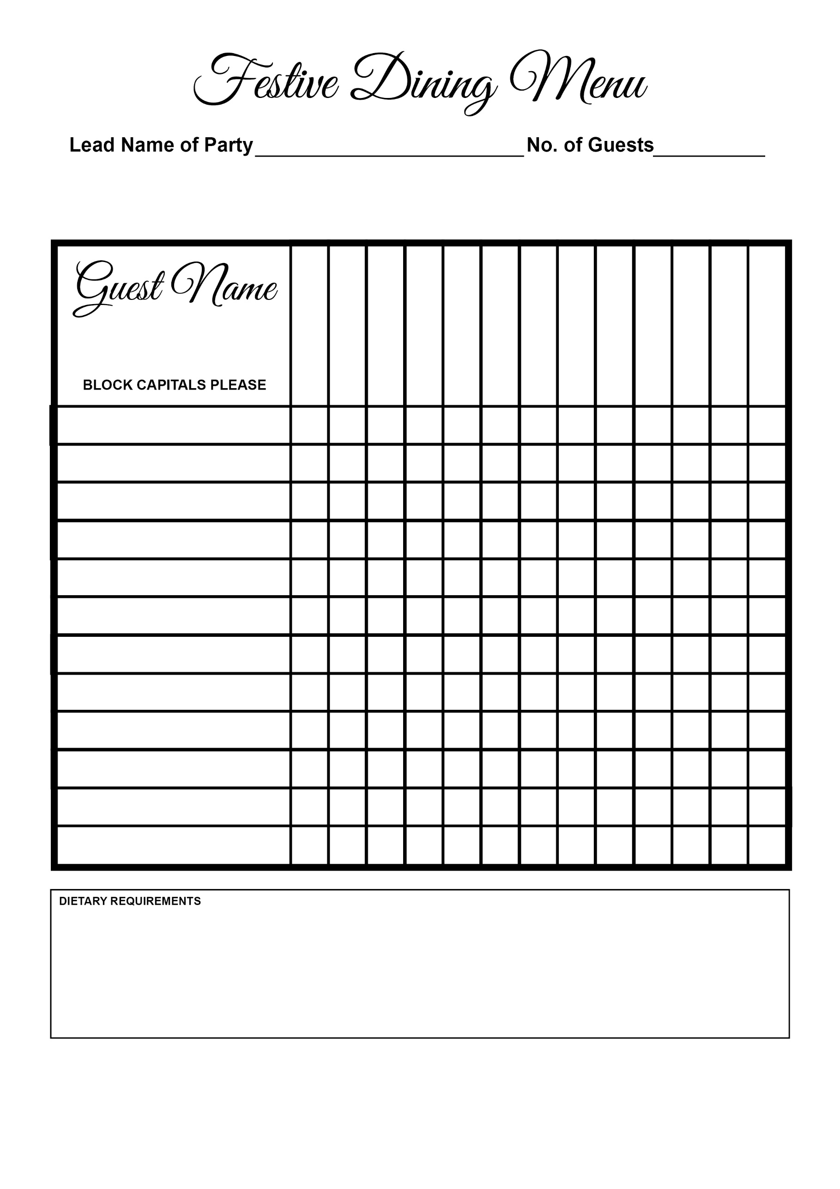

Christmas Pudding

Chocolate Cake

Tart

Goat’s Cheese

Salmon

Beef

Turkey

Prawn

Tarte Tatin

Soup